**Web App / Servlet Project**

**Requirements:**

* Node.js
  + External node packages instructions on how to install are below
* An aws account, or either visual studio eclipse JRE
* Mysql database either rds mysql instance or
  + Install mysql workbench

**How to install and run project:**

* The web app was created using aws
* Aws if you have an account goto the services tab and search for cloud now to create a new environment for your project
* For Visiual studios you just upload the folder that is given and follow same commands in the terminal as aws if node.js is installed in your driver. If you do not have node.js you must install node.js onto ur pc first
  + <https://nodejs.org/en/download/>
  + Goto this link and install node.js into your computer into the driver you wish to use
* If you do not have an aws account we can also use Eclipse or Microsoft Visual Studio
* The project file will be in a zip folder called cs370Project
  + You must unzip this file and upload it
    - Node.js eclipse must be installed for eclipse
      * Goto help in toolbar, click eclipse market place
      * In search bar, search for node

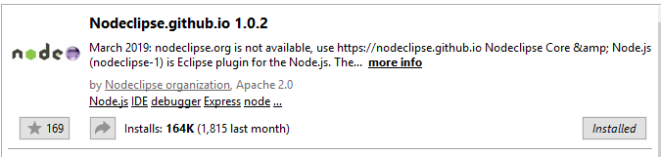

* The image below is how to create a new node.js Project
  + After doing this upload the folder cs370Project into there
  + Our project uses many packages such as
    - Bycrpt
    - Body-parser
    - Curl
    - Ejs
    - Method-override
    - Npm-git-install
    - Passport
    - Passport-local
    - Request
  + These packages are given and you to in our folder
  + For the database you must download the mysql shell
  + This will be done for visual studios and eclipse because the aws is using a rds mysql server so it is done differently
* Create a new database connection and inside that connection create a new schema called cs370.
* Log into root connection and go into Users and Privileges tab and add your account and give it these privileges **ALTER, CREATE, DELETE, DROP, REFERENCES, SELECT, UPDATE**. And click apply

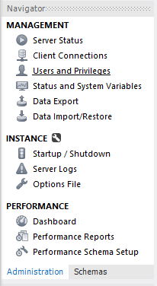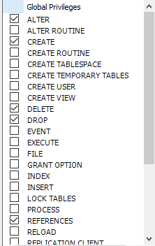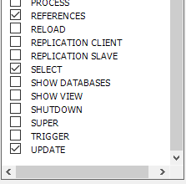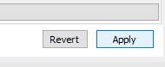

* Now go into the node.js project you opened up in eclipse and open the **models** folder. Open up all the JavaScript files inside the models folder and change the user, host, and password to the new connections user, host, and password you created. The host should be from your localhost so the ip for it will be 127.0.0.1

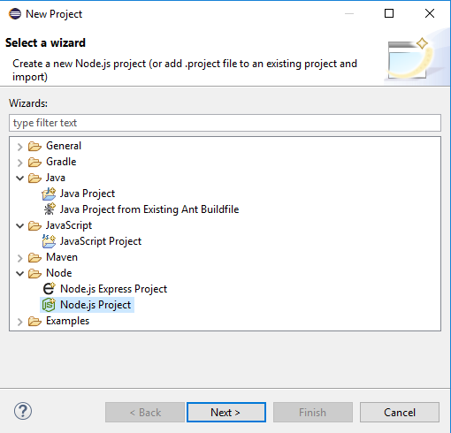

* For visual studio and cloud9 on aws
  + These packages must be installed through the terminal
  + Follow the following commands:
    - npm init
      * this will make you answer questions for the name of the package.json
      * where to start the json your index file
        + such as index.js or like ours is named app.js
    - Npm install node –save
    - Npm install ejs
    - Npm install body-parser
      * This is to use req.body.id and so on to grab parameters to
    - Npm install passport
      * Passport and passport-local is for checking authentication in your database
      * User login and register
    - Npm install passport-local
    - Npm install mysql
      * For your database
    - Npm install method-override
      * object-oriented programming, is a language feature that allows a subclass or child class to provide a specific implementation of a **method**
    - Npm install ejs
      * To create ejs files
    - Npm install bcrypt
      * This encyprts the passwords in your mysql database so no can see it
      * It hashes the passwords
    - Npm install bcrypt-nodejs
    - Npm install express –save
      * Express.js basically helps you manage everything, from routes, to handling requests and views
    - Npm install express-session
    - Npm install connect-flash
* In this project we used Restful routes
* To use passport local you must first create a route to use it
  + We have created a passport this Is done int our app.js file



* + We want to pass the req.user to every template
  + If you go into passport folder and open passport.js this is were passport-local is used
  + We are connected to our database for user and password and we are selecting the rows and columns and either creating a new user by inserting data or checking the database for a preexisting user

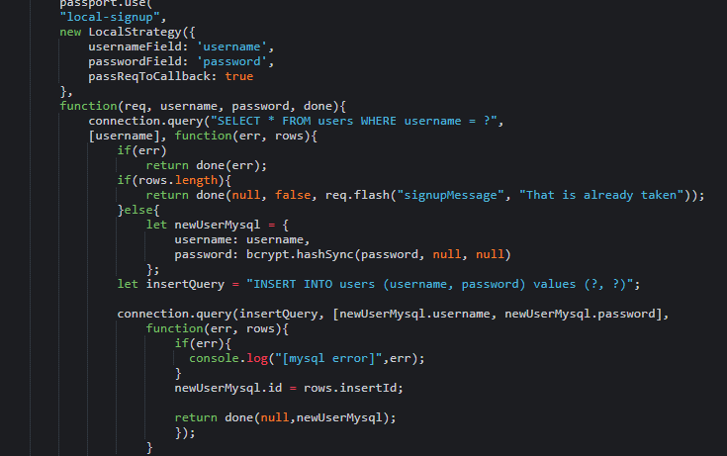

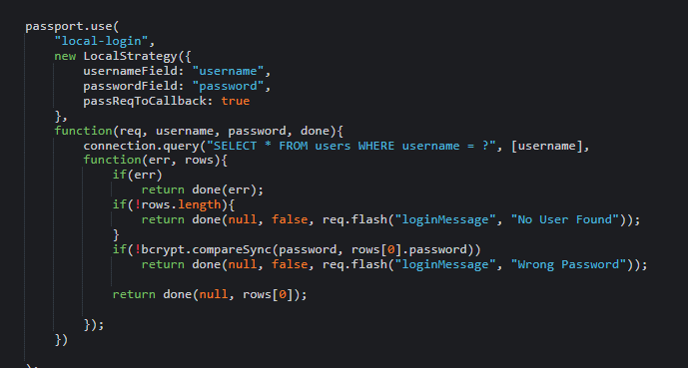

* The scheme and connection scheme is in the models folder
  + We have a campground table
  + Comments table and user table
  + campTable is the connection querie for mysql we export that into our app.js and connect using

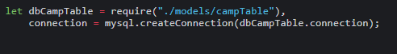

* public folder holds all the css
* views is where our ejs folders and files are, which are later called by our routes to make a post request or a get request from our app.js file
* How to create a rds mysql instance
* In the top-right corner of the AWS Management Console, choose the AWS Region in which you want to create the DB instance. This example uses the US West (Oregon) region.
* In the navigation pane, choose **Databases**.

If the navigation pane is closed, choose the menu icon at the top left to open it.

* Choose **Create database** to open the **Select engine** page.
* On the **Select engine** page, shown following, choose **MySQL**, and then choose **Next**.


                            Select engine
                        

* Click next
  + Specify the db details
* For the ejs folder footer and header are used for your nav bar and link and script tags




                            Specify DB details
                        

* To run on aws cloud9
  + Cd Project
  + Write node app.js

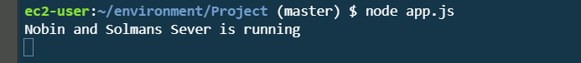

* Goto the toolbar and click Preivew and then goto Preivew Running Application
  + Visual Studio will be the same
* Now you can click run on eclipse and it should show

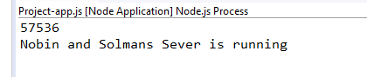

* The number shown on top is the port number your server is running on so you go to a web browser and type in <http://localhost:the-port-number> in my case it would be [http://localhost:57536](http://localhost:57536/) and hit enter.

